Landscape Connectivity Lab
Adapted from Lookingbill & Minor 2017

We will work together on Part 1 in class, and you will be responsible for completing Part 2 on your own.

Part 1. Intro to Landscape-Level Connectivity: Constructing Networks by Hand
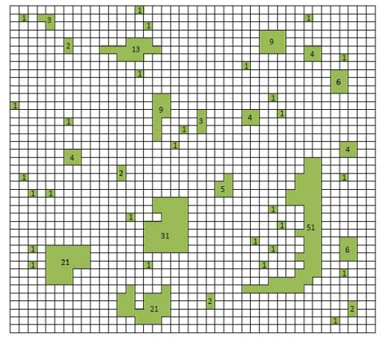
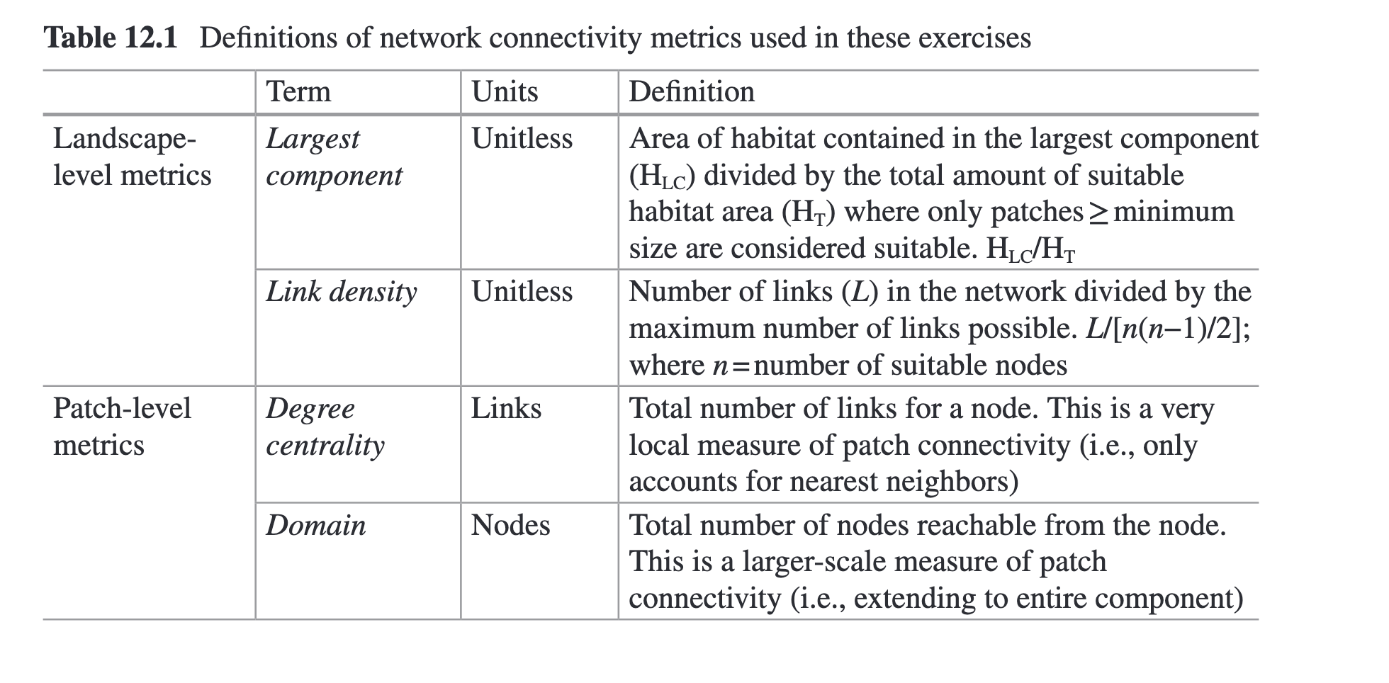
Step 1. Print the map above, or copy to a program where you can draw on it digitally. ( I also put a .png file into the folder for the lab).
Step 2. From this map of potential habitat, identify the suitable habitat patches (or nodes)
that meet the minimum area requirement for a hypothetical small mammal (see
Table below). Shade or color these areas.
Step 3. Next, on either separate pieces of paper/separate pages or in different colors on the same map, identify and shade the patches that meet the minimum area requirements for a
large mammal as defined in Table 1 below (i.e., identify its suitable habitat).
Step 4. Using the maximum dispersal distances (defined in Table 1), draw the links
among nodes of suitable habitat for each of the two species. Links should be
drawn and measured as the shortest distance between patches. To do this, start
counting from the edge of a habitat patch; diagonal distances count as only one
cell length so it is possible to move in eight directions from a given cell (i.e., an
8-neighbor rule). If the edge of a new habitat patch is reached within the allowable
number of steps, then the two patches are connected. Dispersal can occur
across any kind of cell (habitat or nonhabitat).

Step 5. Using the definitions provided in the Slides for this lab, calculate the largest component index and link density for each of the two species and add these values to Table 1.

 | Minimum  habitat  requirement (cells) | Maximum  dispersal  distance (cells) | Largest  component  index (H_{lc}/H_{total}) | Link  Density  L/[n(n-1)/2]
Small  mammal | 1 | 2
Large  mammal | 16 | 32

QUESTIONS FOR PART 1:

Q1 :
- Which species had the greatest connectivity for this landscape according to the largest component index? What about by the measure of link density?

- How do you think the differences in landscape-level connectivity would affect the long-term persistence of the two species on the sample landscape?

- Landscape connectivity measures by themselves may not provide sufficient
information for a species conservation plan. How might the total amount of
habitat and number of patches in each of the networks also be important for
the long-term persistence of a species?

Q2: “Umbrella species” is a term we use to describe a species that is the focus of conservation activities, under the assumption that in protecting that species, other members of its ecological community will also indirectly benefit.

(a) What can you say about the ability to generalize about connectivity from
one species to another based on the results from this exercise?

Q3: A developer would like to remove some of the habitat to create a subdivision on
a parcel of property, four cells in area, somewhere on the landscape.
(a) Where would be the most detrimental place(s) to locate this subdivision (put a circle on the map)? Would this location be the same for the two species?
Provide a rationale for your choice(s).
(b) To offset development elsewhere, the developer is required by law to create
four cells of new habitat somewhere on the landscape.
Where should these four cells go?
Draw the four cells on the map and provide a rationale for your choice.

INSERT A PHOTO OF YOUR MAP HERE:

Part 2. Analyzing Landscape- and Patch-Level Connectivity

In this exercise, you will examine the consequences of landscape connectivity
among protected lands in the Willamette Valley ecoregion of the United States from
the perspectives of a regional planner, wildlife biologist, and pathologist. Below is a map of
the Protected Areas in the ecoregion.
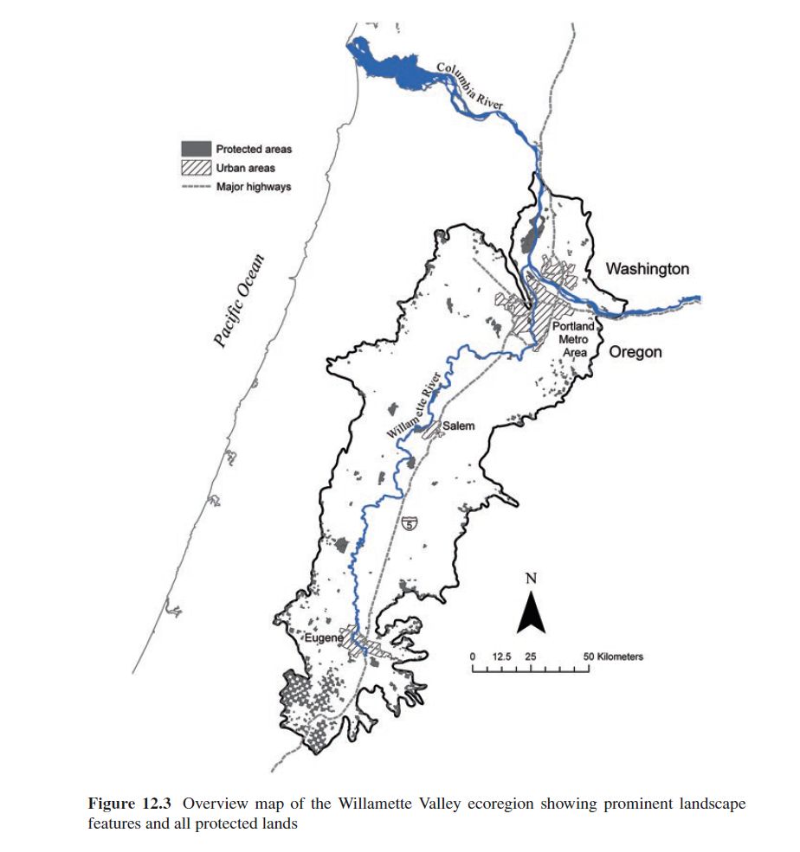
The maps below show the potential landscape networks of three different species for this
map of protected areas (see below). Each species has different minimum area
requirements and movement abilities.
You have also been provided with two tables of Landscape- and Patch-level connectivity metrics for the Protected Areas. Use this information to answer questions about the size and spatial configuration of the protected areas for the three species, and how the life history differences among species should influence their management.
Examine the three separate representations of potential connectivity based on the distribution of protected areas (maps below).
One is for wolves with a home range of 1000 ha and a dispersal distance of 100 km;
The second is for foxes with a home range of 100 ha and a dispersal distance of 10 km;
The third is for mice with a home range of 1 ha and a dispersal distance of 1 km.
Examine the tables of connectivity metrics for each of the three networks (tables below). In particular, note that the second table provides information for individual patches.

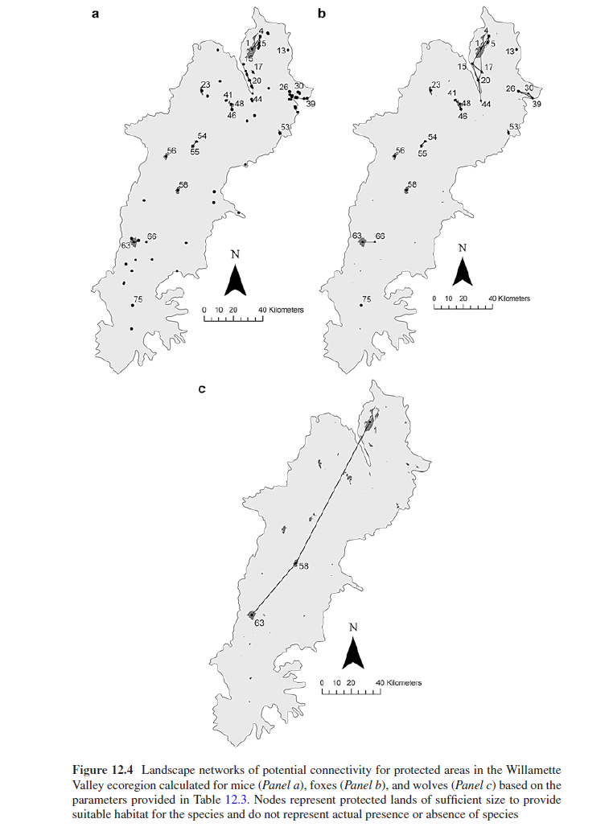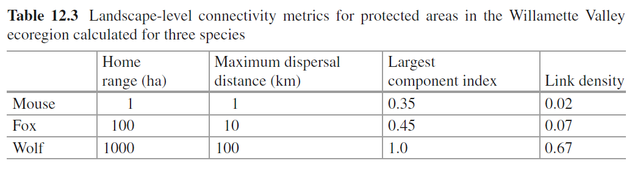

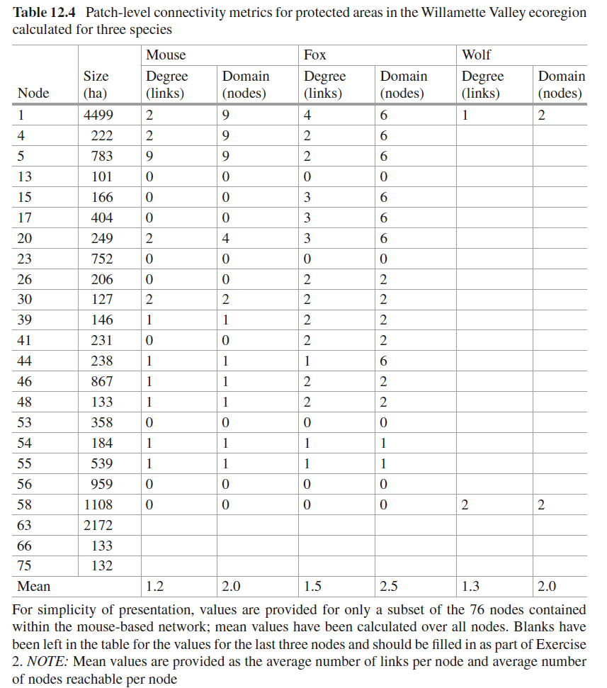

Calculate the missing values in the three bottom rows of Table 12.4. (you can just insert a new table w/ those numbers here, as you won’t be able to actually insert them into the image).

Use the information from the maps and tables to answer the questions below.

Q4: Compare the overall landscape-level connectivity for the three different species
(i.e., largest component index and link density).
(a) Which species would have the highest connectivity assuming it relied solely on protected lands? Which species is potentially least connected?

(b) How do these results compare to your expectations from Exercise 1? Do
you see similar or dissimilar patterns?

Q5: Compare the mean patch-level connectivity metrics for the three species (i.e.,
degree centrality and domain).
(a) Which species seems to be best connected by these measures? Which species
is potentially least connected?

(b) How does this compare with your assessment from Question 4? Which species
would you expect to experience the most problems due to isolation in
the ecoregion according to these results?

Q6: Imagine you were asked to prioritize regional spending for habitat improvement
on protected lands. Consider the relative importance of a specific patch
(patch 1) to connectivity.
(a) Is the patch equally important to the overall, broad-scale connectivity of the
landscape for all three species relative to other protected areas in the ecoregion?
Are other patches more important?

(b) Is the patch equally important to local dispersal movement for all three species
relative to other protected areas in the ecoregion?

Q7: Imagine you were a wildlife biologist tasked with establishing a reintroduction
program for an endangered species of fox. Which patch would be the most logical
location to transplant new individuals to maximize rapid dispersal of the
species to other nearby patches? Include in your justification a statement about
which metric is most important for this type of decision.

Q8: Consider a mouse-borne pathogen that threatens humans and has begun to
invade the ecoregion. Which patches would be logical locations to focus eradication
efforts to try to control the spread of this disease? Include in your justification
a statement about which metric is most important for this type of Decision.

Q9: For learning purposes, several simplifying assumptions were made in this
exercise. For example, what implicit assumptions were made about the matrix
when constructing these networks? What types of land covers and landscape
features might violate these assumptions?

